ASSIGNMENT 10

QUESTION__ **Audio Classification and Smart Phone Notification**

1) Audio collection based on the tags (related to your project)

a. Training Datasets (audio data from smart devices or online sound repositories such as https://www.freesound.org/)

b. Testing Datasets (audio data from smart devices)

2) Audio Classification based on the categories related to your project

3) Notification to smartphone/smartwatch

4) Bonus points:

Music Recommendation system (related to your own project)

a. make a recommendation based on user profile (e.g., preferences, location, gender, age)

b. Recommendation through smartphone/smartwatch using your ML application

**Description:**

1. **Audio Collection: collected sounds of keys and books and divided into training and testing data.**

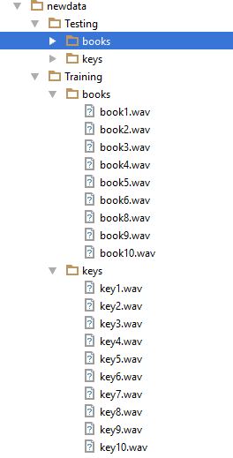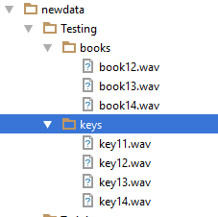

1. **Audio classification based on categories related to your project**

**Training keys and books data and generating features from training audio data:**

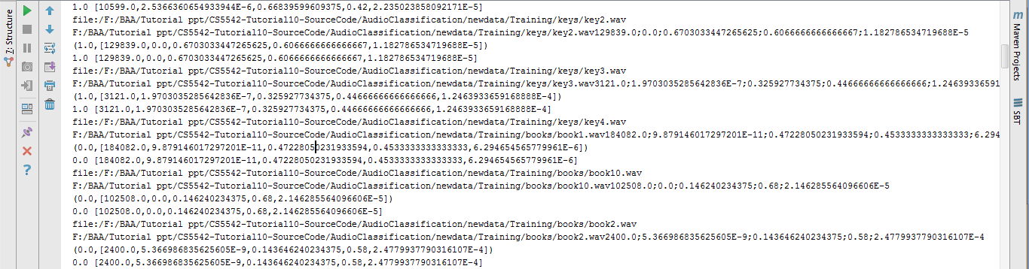

**Feature generation from testing audio data:**

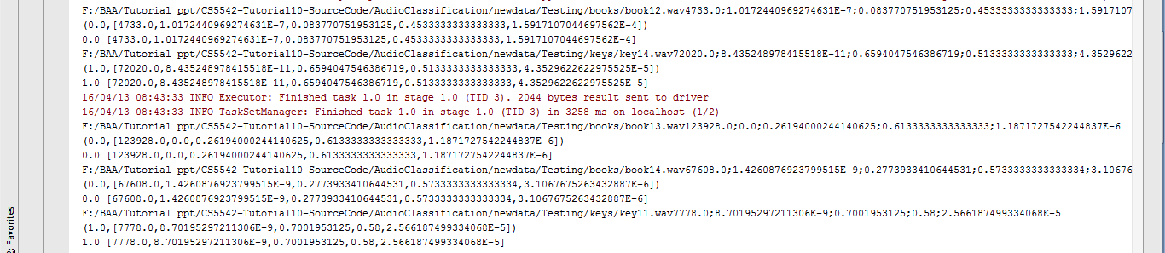

**Accuracy percent: 71%**

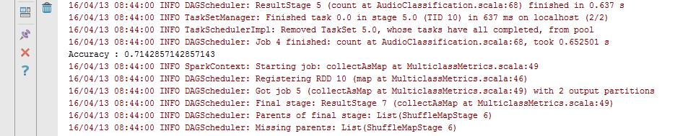

**Confusion matrix: (2+3)/(1+2+3+1)=71.42%**

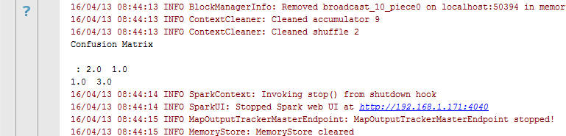

**3. Recommendation To Smart Phone**